DECISION RECORD

Decision Record Number 200

This document records a decision taken by the Police, Fire and Crime Commissioner, together with details of the advice he received prior to taking the decision.

Decision taken
The Police, Fire and Crime Commissioner has taken the decision to:

Agree a Section 22 Agreement in relation to PART II RIPA & PART Ill IPA COMMS DATA COLLABORATION (REG00l.429) in which the five East Midlands forces and South Yorkshire agree to the following:

3.1.1 - "A person, who is an authorising officer for the purposes of section 28 of RIPA by reference to an office, rank or position within one Force, may grant an authority for the carrying out of directed surveillance in accordance with section 28 of RIPA, on an application made by a member of another Force"

This effectively allows an authorising officer from one force to authorise surveillance in an investigation in another force. All costs will be met by the force where the crime occurred.

Details of advice taken

Professional financial and legal advice has been sought to ensure the decision best supports business need and represents value for money.
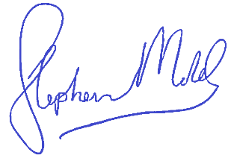

Stephen Mold
Police, Fire and Crime Commissioner
29/03/2021

END

